**SOLAR ENERGY MEASUREMENT SYSTEM**

**ABSTRACT:**

The aim of this project is to measure solar cell parameters through multiple sensor data acquisition. In this project a solar panel is used which keeps monitoring the sunlight. Here different parameters of the solar panel like the light intensity, voltage, current and the temperature are monitored. The microcontroller used here is PIC16F8 family.

The light intensity is monitored using an LDR sensor, voltage by voltage divider principle, current by current sensor and temperature by temperature sensor. All these data are displayed on a 16X2 LCD interfaced to PIC microcontroller.

The power supply consists of a step down transformer 230/12V, which steps down the voltage to 12V AC. This is converted to DC using a bridge rectifier. The ripples are removed using a capacitive filter and it is then regulated to +5V using a voltage regulator 7805 which is required for the operation of microcontroller and other circuits.

**BLOCK DIAGRAM**

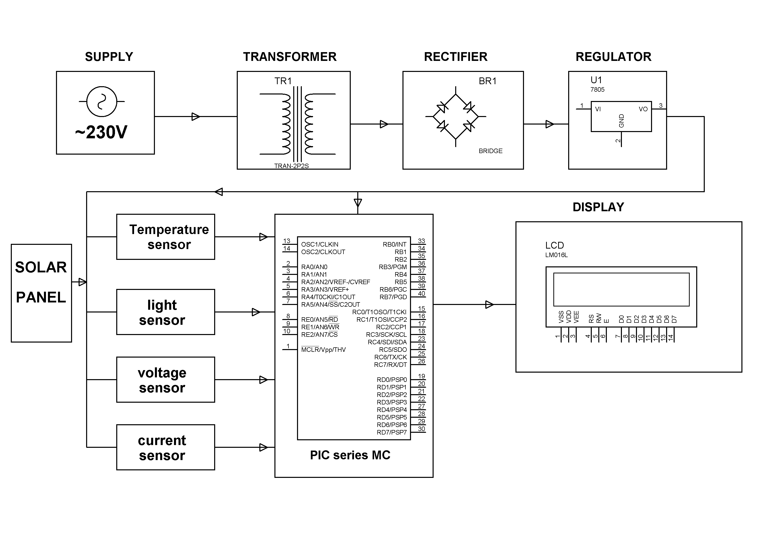

**SOFTWARE REQUIREMENTS:**

MPLAB & HI-TECH PICC Tool suite

Language: Embedded C or Assembly.

**HARDWARE REQUIREMENTS:**

PIC16F8 series MC, Solar Panel, LCD, Transformer, Diodes, Voltage Regulator, Resistors, Capacitor, LED.